Mario Constructor Master
Help Manual

Summary:

Introduction ..................................................
About Mario Constructor Master ..................................................
Launching the Game ..................................................
Title Screen ..................................................
Edit ..................................................
Create Scenario ..................................................
Options ..................................................
Editor Screen ..................................................
Edition ..................................................
Create and Erase ..................................................
Level Preferences ..................................................
Music Set ..................................................
Background Set ..................................................
Spy Set ..................................................
Weather Set ..................................................
Level Informations ..................................................
File ..................................................
Layer Edition ..................................................
Liquid Set ..................................................
Autoscroll Set ..................................................
Bowser Set ..................................................
All Elements ..................................................
Acknowledgments ..................................................

Introduction:
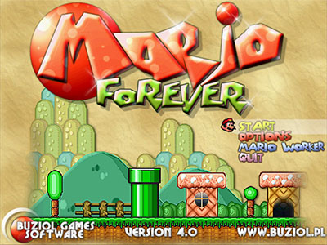
Mario Constructor Master is a fan-game created by Rubisetcie and Mariovariable3410 based on the Nintendo' Super Mario Bros series and Mario Forever created by Michael Gdaniec.

Mario and all relatives are developed by Nintendo®.

About Mario Constructor Master:
Mario Constructor Master is a Level/Game Editor: it provides an easy-to-use interface
in order to help creation of Mario Forever based games.

Launching the Game:
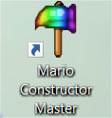

To launch the game, double-click on the shortcut “Mario Constructor Master”.

Title Screen:
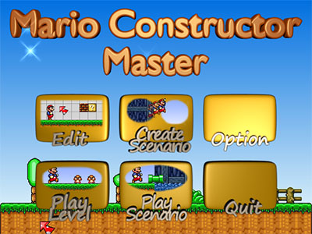
The Title Screen is where the main menu takes place.

It is composed by 6 buttons clickable with the mouse cursor.

Button | Description
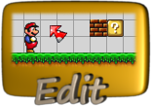 | Takes you to the Editor Screen, which allows you to create levels.
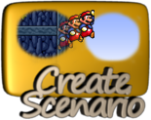 | Allows you to create scenarios or world maps.
 | Takes you to the Option Screen, which allows you to edit some game parameters.
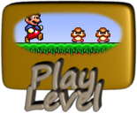 | Loads a single level to play it.
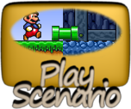 | Loads a scenario or a world map to play it.
 | Closes the game properly.

Title Screen – Edit:
Button | Description
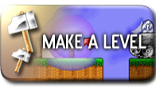 | Creates a new level from scratch.
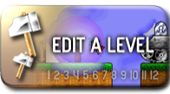 | Loads an existing level to edit it.

Title Screen – Create Scenario:
Button | Description
 | Creates a suite scenario of 32 levels maximum.
 | Creates a compiled suite scenario of 32 levels maximum.  Be careful, you have to move your imported resources to match the scenario's location !
 | Takes you to the Map Editor Screen which allows you to create a world map.

- Suite scenario : Suite of levels not embedded in the “cms” file.
Need to keep existing levels accessible by the scenario file.
Lighter scenario file.
- Compiled scenario : Suite of levels embedded in the “cms” file.
No need to keep existing levels to play scenario.
Heavier scenario file.

Title Screen – Options:
The Option Screen is composed by some parameters :
- Window Size : Set the game window size by some prefabs sizes.
The game window still re-sizable by the mouse!
- Mouse Scrolling : Enable or disable the mouse scrolling use in the editors.
- Music in Editor : Enable or disable the music in the editors.

Editor Screen – Edition:
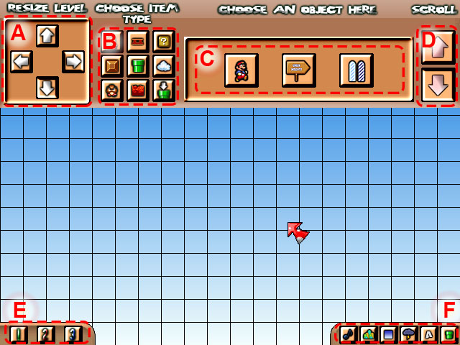
Edition screen reference:
Element | Description
A | Resize level:  é : Decrease height by 15 blocks.  ⬇ : Increase height by 15 blocks.  ⬅ : Decrease width by 20 blocks.  ➔ : Increase width by 20 blocks.
B | Category buttons (see Create and Erase section for details).
C | Element buttons (see All Element section for details).
D | Scroll buttons, used to scroll through elements of same category.
E | Layer buttons, used only with Tiles of Pipe Objects:  1 : Background layer, not solid, objects are drawn in front of.  2 : Middle layer, solid, same depth of objects.  3 : Foreground layer, not solid, objects are drawn behind.
F | Preferences buttons (see Level Preferences section for details).

Editor Screen – Create and Erase:
The level editor works by adding or removing elements:
Category | Description
 | Essential Objects:  Start / End points, and checkpoints.
 | Platform Objects:  Moving and falling platforms, multiple skins, and springs.
 | Bonus Objects:  Item blocks, breakable bricks and collectable coins.
 | Tileset:  Backbone of a level, immobile blocks placeable on layers.
 | Pipe Objects:  Immobile pipes elements, multiple colors.
 | Scenery Objects:  Static decoration objects.
 | Enemy Objects:  Movable enemies objects.
 | Hazardous Objects:  Static dangerous objects.
 | Warp Objects:  Create pipe warps, use them to switch section.

Use the Left Click to put elements on the grid and Right Click to erase elements on the cursor:
Warning:
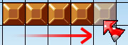Creating objects
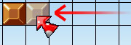Erasing objects
Using Right Click, you can remove objects from the selected category only!
E.g.: you cannot remove a bonus block by selecting a tileset block.

Editor Screen – Level Preferences:
The preferences are the setup of the level (like its name, its background...):
Button | Description
Music set:
Set the ambient music of the level.
Background set:
Set the background image of the level.
Sky set:
Set the sky color or gradient of the level.
Weather set:
Set the weather effects of the level.
Title set:
Set various preferences of the level (see Title Set for info).
Switch section:
Switch between the two sections A and B.

Editor Screen – Music Set:
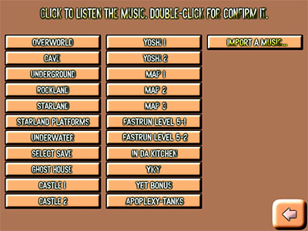
Set the ambient music of your section
among 22 available songs.

You can also import a custom song !

Note: only the following formats are
supported:
“aiff, asf, asx, dls, flac, fsb, it, m3u, mid,
mod, mp2, mp3, ogg, pls, s3m, vag, wav,
wax, wma, xm, xma”
Editor Screen – Background Set:
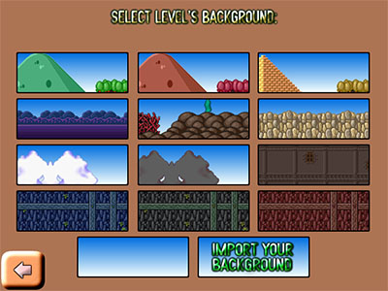
Set the background image of your section
among 12 available pictures.

You can also import a custom background!

Note: only the following formats are
supported:
“bmp, dds, jpg, png, tga, psd”

Editor Screen – Sky Set:
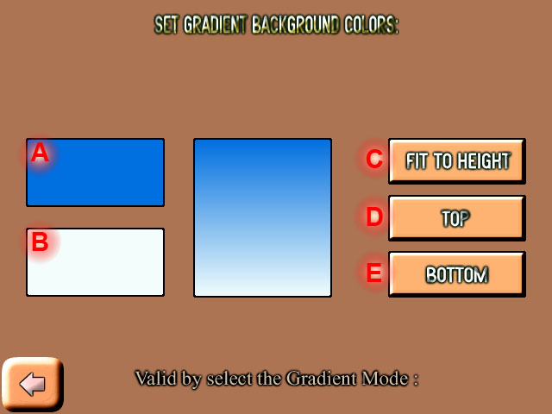
Change the sky gradient color:
Element | Description
A | Click to set the top color.
B | Click to set the bottom color.
C | Set the gradient height to fit the level height.
D | Set the gradient height to the top of the level.
E | Set the gradient height to the bottom of the level.

Note:
The gradient mode corresponds to the position of the sky in your level:
- Fit to Height : The sky gradient is stretched to fit the level's height.
- Top : The sky gradient is positionned to the level's top.
- Bottom : The sky gradient is positionned to the level's bottom.

Editor Screen – Weather Set:
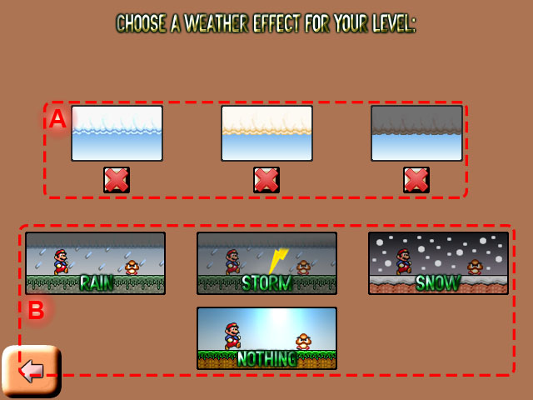
Set the weather effects of your section:

Element | Description
A | Set the cloud color.
B | Set the weather effects.

Editor Screen – Level Informations:
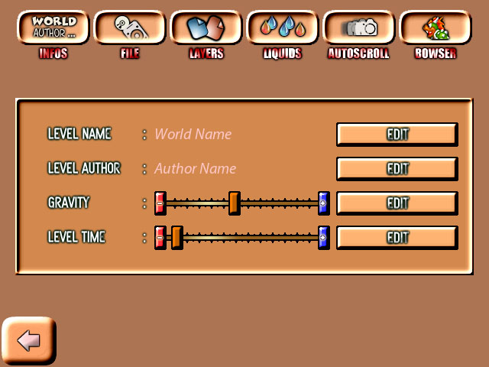
Set some alpha-numeric informations of
your level:

Information | Limits
Level name | Max characters: 21
Level author | Max characters: 31
Gravity | Between 1 and 10
Level time | Between 100 and 10 000

Editor Screen – File:
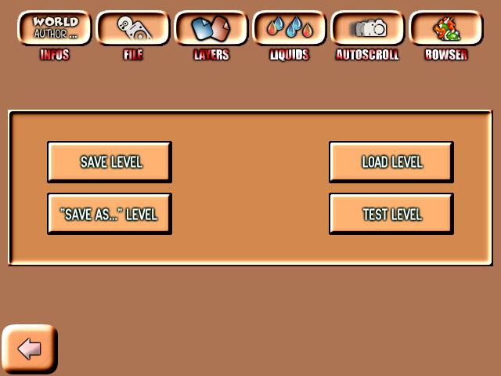
Buttons that allows you to interact with
level files:

Button | Description
Save | Save your level.
Save as | Save your level to another filename.
Load | Load a “cml” level file.
Test | Give a try to your level.

Editor Screen – Layer Edition:
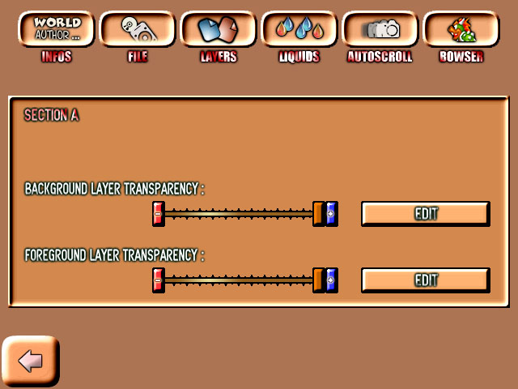
Set the layers transparency of the section:

Slider | Description
BG Layer | Transparency of the BG.
FG Layer | Transparency of the FG.

Editor Screen – Liquid Set:
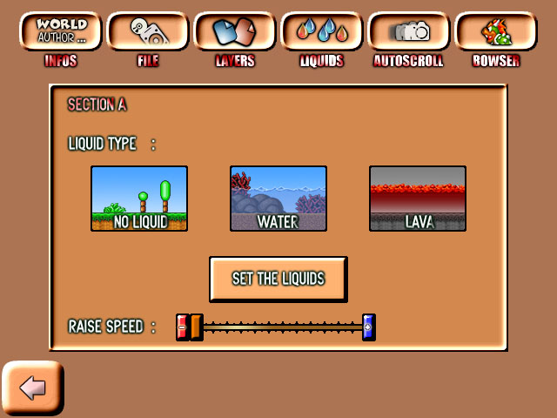
Set the liquid parameters of the section.
You can add a “liquid” (water or deadly lava),
and edit his “behavior”:
Button | Description
 | Set the liquid start height.
 | Place the “liquid triggers".

Slider | Description
Raise speed | Speed of raising liquid.

Note:
“Liquid triggers” stands for invisible rectangles that raise or lower the liquid
level when the player enter them in game.

Editor Screen – Autoscroll Set:
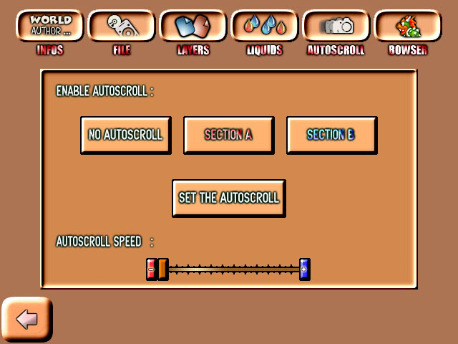
Set the automatic screen scrolling for a
section of your level.
You can select the section you want to
enable the autoscroll.
Then, click on “Set the Autoscroll” to set
his path by adding nodes:

Slider | Description
Autoscroll speed | Speed of the scrolling.

Editor Screen – Bowser Set:
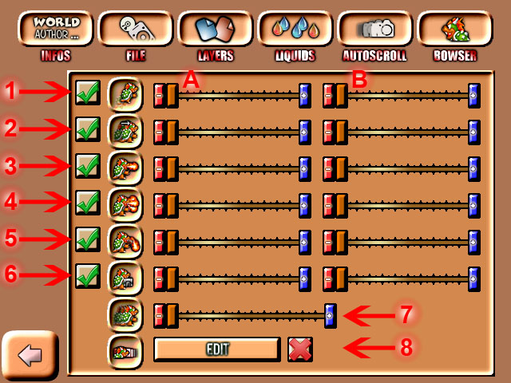
Set the behavior of Bowser (attacks, frequencies and speed).

Click on the marks to enable or disable his
skills.

You can set his health in an efficient range.

You can also enable a cosmetic “trail effect”.

Behavior | Description |  | Slider | Description
1 | Enable or disable the jump move. |  | A | Speed of the move.
2 | Enable or disable the horizontal moves. |  | A | Speed of the move.
3 | Enable or disable the single fire spit. |  | A | Speed of the move.
4 | Enable or disable the triple fire spit. |  | A | Speed of the move.
5 | Enable or disable the homing fire spit. |  | B | Frequency of the move.
6 | Enable or disable bullet bill cannon hold. |  | B | Frequency of the move.
7 | Set the length of the trail effect. |  | B | Frequency of the move.
8 | Set the health of Bowser. |  | B | Frequency of the move.

All Elements :
Element | Description
 | Player start:  Its placement define the player start position.  Can only be placed once per level.
 | Checkpoint:  Saves the player's progress through the whole level.  A level can contain more than only 1 checkpoint.
 | Level goal:  The level's end point. The player can jump over the arrow marker to try to touch the moving bar, in order to get a higher score.
 | Moving platform - Continuous:  Platform that start moving back and forth horizontally or vertically at the beginning of the level. 4 different skins and size exists.
 | Moving platform - Touch:  Platform that start moving forward horizontally or vertically once the player steps on it. 4 different skins and size exists.
 | Falling platform:  Platform that fall beneath the player once the player steps on it.  4 different skins and size exists.
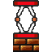 | Red spring:  Catapults the player when he steps on it. You can be catapulted higher if you press the jump button at the right moment. Force : 1
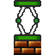 | Green spring:  Catapults the player when he steps on it. You can be catapulted higher if you press the jump button at the right moment. Force : 2
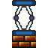 | Blue spring:  Catapults the player when he steps on it. You can be catapulted higher if you press the jump button at the right moment. Force : 3
 | Switch & Toggle block:  Blocks that can turn solid or non-solid by hitting a same colored switch.

Element | Description
 | Mushroom powerup:  Transforms small-Mario into big-Mario, making the player stronger with the ability to break brick blocks.
 | Flower powerup:  Transforms Mario into fire-Mario, giving him the ability to shoot fireballs with the run button and defeat enemies in front of him.
 | Beetroot powerup:  Transforms Mario into beet-Mario, giving him the ability to shoot vegetables with the run button and defeat enemies asides him.
 | Lui powerup:  Transforms Mario into lui-Mario, increasing his jump and run skills.
 | Star bonus:  Makes Mario invincible for a brief moment.  While Mario is invincible, he can kill the enemies by touch them.
 | 1-UP bonus:  Gives the player one extra-life.  The maximum number for lives is 99.
 | Question block:  If the player hit this solid block from the bottom, it gives him a bonus.
 | Invisible block:  Non-solid except from the bottom.  If the player hit this block from the bottom, it gives him a bonus.
 | Invisible block:  An Invisible block that can be hit only once : if the player dies after hitting this bonus block, it will contain a regular coin instead.
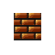 | Breakable break:  A solid block that can be broke if big-Mario hit it from the bottom.  Small-Mario can't break it.
 | Coin bonus:  Gives the player one extra-life when he grabs 100 coins.  The maximum number for lives is 99.

Element | Description
 | Brown goomba:  Basic enemy that moves forward and can be killed easily with stomping.
 | Grey goomba:  Basic enemy that moves forward and can be killed easily with stomping. Immune to flower fireballs.
 | Spiny:  Basic enemy that moves forward. Cannot be stomped.
 | Grey spiny:  Basic enemy that moves forward. Cannot be stomped and immune to flower fireballs.
 | Buzzy-beetle:  Once he has been stomped, you can shoot his shell to strike enemies.
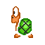 | Green koopa-troopa:  Once he has been stomped, you can shoot his shell to strike enemies.
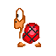 | Red koopa-troopa:  Once he has been stomped, you can shoot his shell to strike enemies. He moves faster, and he turns back when he faces a gap.
 | Blue koopa-troopa:  Once he has been stomped, you can shoot his shell to strike enemies. He moves at the same speed as Red koopa-troopa.
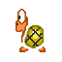 | Yellow koopa-troopa:  He runs fast towards the player until he has been stomped.  As a koopa-troopa, you can shoot his shell to strike enemies.

Element | Description
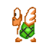 | Green para-troopa:  A flying koopa, looses his wings when stomped.  He moves back and forth along an axis (vertical or horizontal).
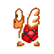 | Red para-troopa:  A flying koopa, looses his wings when stomped.  He moves back and forth along an axis (vertical or horizontal).
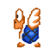 | Blue para-troopa:  A flying koopa, looses his wings when stomped.  He moves back and forth along an axis (vertical or horizontal).
 | Green jumping para-troopa:  Flying koopa, looses his wings when stomped.  He makes low bounces while moving forward.
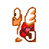 | Red jumping para-troopa:  Flying koopa, looses his wings when stomped.  He makes low bounces while moving faster than the green one.
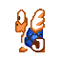 | Blue jumping para-troopa:  Flying koopa, looses his wings when stomped.  He makes high bounces while moving at the same speed as reds.
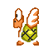 | Yellow para-troopa:  Flying koopa, that chases the player in the air.  When hit, he turns into Yellow koopa, and chases on the ground.
 | Green piranha plant:  Moves slowly in and out of a pipe (not mandatory but generally).  If the player stands near his lair, he won't get out until he leaves.
 | Pink piranha plant:  Moves slowly in and out of a pipe (not mandatory but generally).  No exit if the player is near, fires 3 fireballs when fully exit his pipe.
 | Grey piranha plant:  Moves slowly in and out of a pipe (not mandatory but generally).  Cannot be killed from flower fireballs.

Element | Description
 | Red cheep-cheep:  If in water: swims forward, with no cares about anything.  If out of water: jumps once at the player.
 | Green cheep-cheep:  If in water: swims faster than reds, with no cares about anything.  If out of water: jumps once at the player.
 | Blue cheep-cheep:  If in water: swims back and forth, turning back if he hits a wall.  If out of water: jumps once at the player.
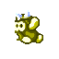 | Yellow cheep-cheep:  If in water: chases the player in water. Immune to flower fireballs.  If out of water: jumps once at the player, cannot be stomped.
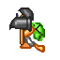 | Hammer brother:  Moves randomly and throws harmful hammers to the player.  If he's put above or beneath a free space, he will be able to jump.
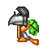 | Silver-hammer brother:  Moves randomly and throws silver hammers to the player, that bounces on walls and can break breakable bricks. He still can jump.
 | Fire brother:  Moves randomly and throws fireballs to the player.  If he's put above or beneath a free space, he will be able to jump.
 | Beet brother:  Moves randomly and throws vegetables to the player.  If he's put above or beneath a free space, he will be able to jump.
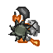 | Spike brother:  Moves randomly and throws spike-balls to the player.  If he's put above or beneath a free space, he will be able to jump.
 | Poison mushroom:  A deadly mushroom that kills you instantly. You can still find it inside regular bonuses blocks. Be careful.

Element | Description
 | Static plant:  An immobile animated plant that hurts the player.
 | White lakitu:  Follows the player and throws spinies at him.  Unlike in Mario Forever, if he's killed, he won't coming back.
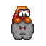 | Dark lakitu:  Follows the player and throws grey spinies at him.  Unlike in Mario Forever, if he's killed, he won't coming back.
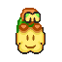 | Golden lakitu:  Friendly enemy that follows the player and throws coins at him.  He is totally harmless.
 | Thwomp:  Falls straight to the player when he pass right below/above him.
 | Bowser:  The ultimate boss, moves randomly and spit fire. You can set his behavior in the options. The level is beaten after his defeat.
 | Lava:  Deadly lava that kills the player instantly.
 | Podoboo:  A big fireball that jumps of the lava (not mandatory but generally).  You can set its height.
 | Jumping podoboo:  Spits a dozen of podoboos regularly from the lava (not mandatory but generally).
 | Spike:  An immobile spike that hurts the player.

Element | Description
 | Bullet-bill cannon:  An immobile cannon that shots stompable bullet-bills.  If the player stands near, it won't shot until he leaves.
 | Homing bullet-bill cannon:  An immobile cannon that shots stompable homing bullet-bills.  If the player stands near, it won't shot until he leaves.
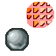 | Roto-disc:  A harmful disc that rotates around a circle center.  There is a variant with a variable radius.
 | Lava launcher:  An immobile cannon that spits harmful lava regularly.
 | Spike launcher:  An immobile cannon that shots harmful spike-balls regularly.
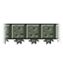 | Centipede platform:  A platform that starts following a path when the player steps on it.  Unlike moving platforms, it won't “transport” the stepping player.
 | Warp:  An invisible warp that transports the player from a position to another one (one way).  You can create a link between sections.  Usually used on pipes but that's not mandatory.  To be valid, the warp has to not be placed inside solid blocks but above them!

Acknowledgments:
I would like to thanks Mariovariable3410 which helps me with the graphics and
the alpha-testing.
I would like to thanks too Radel1996 for the beta-testing.

And at last, I would like to thanks all the players who downloaded the game!

Mario and all relatives are developed by Nintendo®.

